**Reporting on the NAXT systems**

The Reports available on the new system are provided in different ways:

1. Some reports are provided on the **Reports menu of your NAXT screen**.  These will be reports that are used on a very regular basis and may need no or little in the way of selection, i.e. you may change a date range. See SOP below:

[**REP_1.1(SOP)Reports Guide**](http://training.goughgroup.co.nz/Shared%20Documents/REP_1.1(SOP)Reports%20Guide.docx)- how to run reports in the NAXT system

1. Pre-written reports can be accessed by a wider group of users **through SSRS Web Portal** (previously Report Manager).  This method is normally used for existing reports and reports that are run in the same format on a regular basis.  Users can access the reports themselves and are subject to security protocols in accessing these reports.

[**REP_1.3(SOP)BI Report Guide**](http://training.goughgroup.co.nz/Shared%20Documents/REP_1.3(SOP)BI%20Report%20Guide.docx)- how to run reports over the BI Cubes

1. Other less frequent ad-hoc reports will be created by specialist users “mining” the report information **from the Business Intelligence (BI) cubes**.  This is done via Microsoft Excel.  See SOP below:

[**REP_1.2(SOP)Basic eMerge BI Training**](http://training.goughgroup.co.nz/Shared%20Documents/REP_1.2(SOP)Basic%20eMerge%20BI%20Training.docx)    - how to access the BI Cubes

(Specialist users will have access rights to allow this type of reporting).

**Before you start:**

There are a couple of set ups required, so please check that you have the appropriate access:

1. **If you are using SSRS Reports (see 2 above)**
2. Check that you can access the Web Portal for SSRS Reports – check that you can follow the link below – suggest you save the website as a favourite

[**http://chcaxdw1/Reports/Pages/Folder.aspx?ItemPath=%2fGough+NAXT+Reports&ViewMode=List**](http://chcaxdw1/Reports/Pages/Folder.aspx?ItemPath=%2fGough+NAXT+Reports&ViewMode=List)

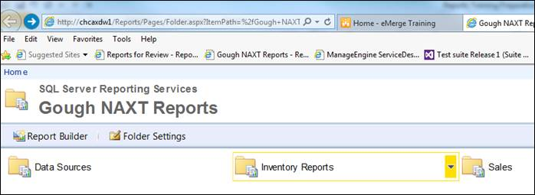

1. Click on the Inventory Reports and ensure that you can open a report
2. **If you are using BI Reports (see 3 above)**
3. You will need to set up a Data Connection for the following BI Cubes

**Goughs_dwh_cubes>fact_inventory summary**

**Goughs_dwh_cubes>fact_sales_invoice**

          See Steps 1 – 10  of    [**REP_1.2(SOP)Basic eMerge BI Training**](http://training.goughgroup.co.nz/Shared%20Documents/REP_1.2(SOP)Basic%20eMerge%20BI%20Training.docx)for instructions on how to do this.

Note: Product /Regional/Branch Managers can access Sales Invoice Cube and Inventory Cube; Accountants can also access the General Ledger Cube.

1. Please ensure that you have access to the following Drive Path:

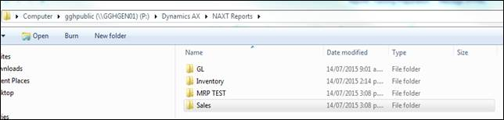

1. Open a report from the Inventory and Sales folders

If you have any difficulties with these, please contact the helpdesk as it is important that you have the correct access.